AV Tech System Documentation
Mackie DL32SE Mixer and Master Fader SE Guide
Draft module for the church AV / streaming manual - prepared 2026-05-19

Document status
This module is written without current Master Fader screenshots. It is suitable as a text/reference baseline now, and screenshots can be inserted later in the same style as the Task Scheduler and ER605 documentation modules.

1. Purpose of this document
This document explains the Mackie DL32SE digital mixer and the Master Fader SE control app as part of the church AV technology system. It is intended for a future volunteer, technician, or maintainer who needs to understand what the mixer does, why it was installed, how it fits the livestream system, and how auxiliary mixes are used for streaming and other speaker zones.

2. What the DL32SE is
The Mackie DL32SE is a rack-mount digital mixer. Unlike an older analog mixer with physical knobs and faders on the surface, the DL32SE is controlled primarily through software. It lives in the AV cabinet and provides microphone preamps, signal processing, routing, USB audio, and multiple independent output mixes.
Feature | Why it matters in this AV system
32 input channels with Onyx+ preamps | Enough inputs for wired microphones, wireless microphones, instruments, playback, and future expansion.
10 fully assignable XLR outputs | Allows main room sound, stream feeds, auxiliary speaker feeds, and monitor-style outputs to be routed separately.
8 stereo-linkable aux sends | Allows independent mixes for streaming, monitors, overflow rooms, or auxiliary amplifiers.
Master Fader SE control app | Allows control from the BeelinkOBS PC, tablet, or other approved devices on the AV network.
32x32 USB audio interface | Can send mixer audio to a computer for OBS/recording and receive computer playback when configured.
Snapshots, presets, mute groups, VCAs, processing | Allows repeatable setup and faster recovery if settings are accidentally changed.

Mackie documentation describes the DL32SE as a 32-channel digital rack mixer controlled with Master Fader SE, with 32 inputs, 10 assignable XLR outputs, 8 stereo-linkable aux sends, and a 32x32 USB audio interface. See the source list at the end of this document.

3. What Master Fader SE is
Master Fader SE is the control app for the DL32SE. In normal use, the mixer hardware handles the audio, while Master Fader SE provides the control surface on a Windows PC, tablet, or other supported device. In this church system the app is part of the operator workflow because the physical mixer in the cabinet does not provide a traditional full-size fader surface.
- Use Master Fader SE to control channel faders, mutes, gain-related settings, EQ, dynamics, aux sends, outputs, routing, snapshots, and user access limits.
- The mixer connects by Ethernet to the church AV network. Wireless control from a tablet is provided by the AV access point, not by relying on a built-in Wi-Fi mixer hotspot.
- The BeelinkOBS PC can run Master Fader SE so the main streaming computer can also monitor or adjust the audio mix when required.
- Access limiting should be considered if other volunteers or tablets are allowed to connect, so accidental changes to critical routing are less likely.

4. Why the DL32SE replaced the old Yamaha mixer
The previous church mixer was a 32-channel Yamaha analog mixer. It was functional for traditional room sound, but the expanding livestream and AV requirements made a digital rack mixer more practical.
Need / problem | How the DL32SE helps
Separate livestream sound from room sound | Aux sends allow a dedicated stream mix that can be adjusted independently from the sanctuary main mix.
Remote control from the sound position or tablet | Master Fader SE allows control from a PC or tablet on the AV network. The operator does not have to stand at the rack.
Repeatable settings | Snapshots and saved shows make it easier to restore a known-good setup for Sunday service.
More flexible routing | Assignable outputs and USB routing can feed OBS, auxiliary amps, overflow spaces, or monitor sends.
Better integration with streaming | The mixer can feed OBS by USB/ASIO or feed a camera/audio input path depending on the chosen Stream Agent/OBS setup.
Less physical rewiring for changes | Many routing changes can be made in software rather than moving cables or repatching an analog board.

Important practical reason
The DL32SE was not chosen simply because it is newer. It was chosen because streaming requires a dependable, repeatable, separate broadcast audio mix. The old analog mixer was less convenient for this kind of routing, recall, and remote operation.

5. How the mixer fits into the streaming system
The DL32SE is the central audio routing device. Stream Agent III controls OBS and cameras, but the DL32SE/Master Fader system controls the actual church audio mix. The two systems meet at OBS or at the selected camera/audio input path.
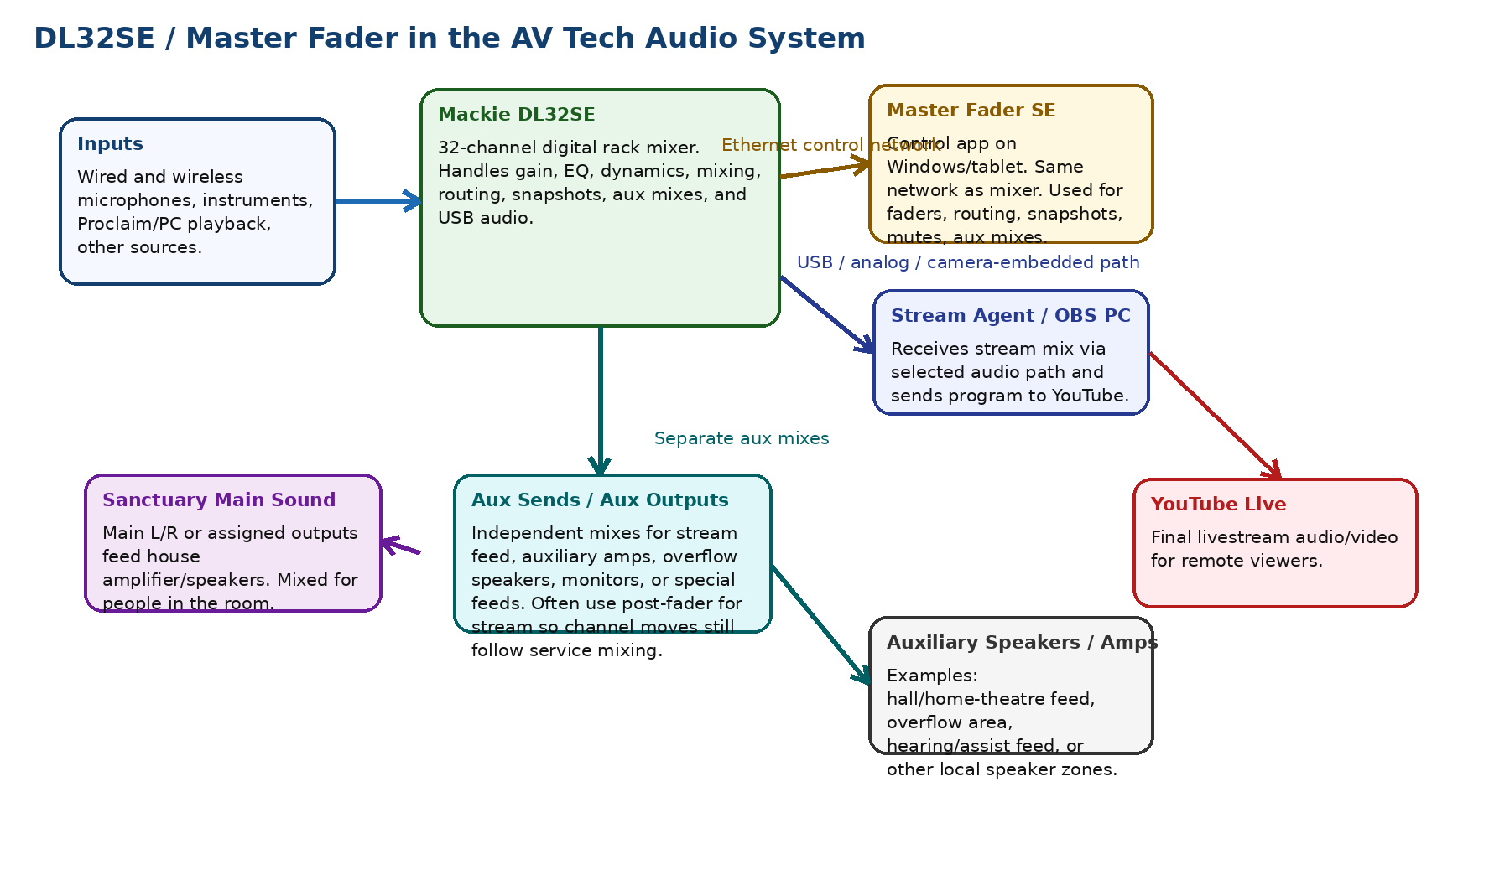
Figure 1 - Conceptual role of the DL32SE and Master Fader SE in the AV tech system.

6. Main room mix versus stream mix
A major reason for the DL32SE is that the mix heard in the room is not always the same as the mix needed online. The room already contains natural sound from voices, instruments, and speakers. Online listeners hear only what the stream receives.
Mix | Typical destination | Main concern
Main L/R or main assigned output | Sanctuary amplifier and speakers | Comfortable sound level and clarity for people physically in the room.
Dedicated stream aux mix, often Aux 3 in this project history | OBS / Stream Agent / camera audio path / YouTube | Clear speech and music for online listeners, independent of room acoustics.
Other aux outputs | Auxiliary amps, overflow speakers, monitors, hall/home-theatre feed, special zones | Give each area only the sound it needs, at its own level.

In the project history, Aux 3 has often been used as the dedicated stream mix. This is a good design because the stream feed can be tuned for YouTube without forcing unwanted changes to the sanctuary sound. The exact final routing should be verified in Master Fader SE and recorded in the future screenshot-based revision of this document.

7. Understanding aux sends and aux outputs
An aux send is an independent send level from each input channel to an auxiliary mix bus. An aux output is the physical or routed output that carries that aux mix to another device. The important idea is that each aux mix can be different from the main room mix.
- A channel can be loud in the room but quieter in the livestream aux mix.
- A channel can be muted or low in an auxiliary speaker zone if that source is not needed there.
- A stream aux can be set post-fader so normal service fader changes still follow the operator, while retaining separate stream-send trims.
- Monitor or auxiliary speaker feeds may be pre-fader or post-fader depending on whether they should follow main fader moves.
- A single physical aux output can feed an amplifier, powered speaker, camera input, interface input, or other destination if levels and cabling are correct.

7.1 Pre-fader versus post-fader concept
Aux tap type | Plain-English meaning | Typical use
Pre-fader | The aux send is less affected by the channel fader used for the room mix. | Stage monitor or special feed where the room fader should not disturb that mix.
Post-fader | The aux send follows the channel fader. If the operator turns the microphone up/down for the room, the aux feed tends to follow. | Livestream mix where the stream should generally follow the live service mix, but still have its own send levels.
Pre-DSP / other tap points | The send may be taken before some processing, depending on mixer settings. | Advanced cases only. Avoid changing unless the reason is documented.

Recommended operating idea
For the YouTube stream mix, a post-fader aux is often the easiest volunteer-friendly choice: the main fader move still helps the stream, but the stream aux send level can be adjusted separately for sources that need different online balance.

8. Suggested/documented audio routing model
The following model reflects the project history and current Stream Agent III sd design. It should be checked against the live Master Fader SE routing screen and corrected if the physical system has changed.
Route | Purpose | Notes / verify later
Inputs -> DL32SE channels | All microphones, instruments, and playback enter the mixer. | Label channels clearly in Master Fader SE.
DL32SE Main/assigned outputs -> sanctuary sound | Feeds main speakers/amps for the room. | Do not tune only from YouTube return; tune the room independently.
DL32SE Aux 3 -> stream audio path | Dedicated YouTube/OBS mix. | Project history identifies Aux 3 as the stream mix. Verify final output/USB/camera path.
DL32SE USB or analog/camera path -> OBS | Carries the stream mix to the video encoder. | Stream Agent supports asio_shared and axis_embedded audio modes; document the final chosen mode.
Other aux sends -> auxiliary amps/speakers | Feeds overflow/hall/home-theatre/monitor-style zones. | Each aux mix can be independent. Label cables and outputs.
PC/Proclaim playback -> mixer stereo return or input channels | Allows videos/music from Proclaim/PC to be heard. | Avoid routing playback back into itself; watch for feedback loops.

9. Operating overview for Sunday service
- Power on the AV cabinet equipment as documented for the site.
- Confirm the DL32SE is powered and connected to the AV network through Ethernet.
- Confirm the Master Fader SE app launches on BeelinkOBS or the control tablet.
- Confirm Master Fader SE can see/connect to the DL32SE.
- Recall or verify the correct church show/snapshot if that workflow is used.
- Check that the main room microphones and music sources are active and at reasonable levels.
- Check the dedicated stream aux mix and confirm OBS/Stream Agent receives audio.
- Use Master Fader SE for audio mixing; use Stream Agent III sd for stream/camera/director control.
- After service, leave the system in the documented state for the next operator.

10. Master Fader SE areas to document later with screenshots
Screenshots are not included in this first draft. The following areas should be captured later and inserted into this document.
Screenshot area | Why it matters
Mixer connection screen | Shows how to connect Master Fader SE to the DL32SE on the AV network.
Main mixer/fader view | Shows channel layout and naming used by volunteers.
Aux 3 / Stream Mix view | Shows the dedicated stream mix levels and tap point/post-fader behavior.
Output routing screen | Shows which aux/output/USB paths feed OBS, cameras, amps, or speakers.
USB routing / I/O patch screen | Important if OBS receives audio over USB/ASIO.
Snapshots/shows page | Shows how to restore the normal church setup.
Access limiting / user permissions | Important if tablets or volunteer devices are allowed to connect.

11. Troubleshooting
Symptom | Likely causes | First checks
Master Fader cannot find mixer | Mixer not powered, Ethernet cable problem, wrong network, AP/router issue, Windows firewall/network profile. | Check DL32SE power/link lights, ER605/AP network, BeelinkOBS IP, and whether tablet/PC is on the AV LAN.
Room sound works but stream is silent | Stream aux not receiving signal, USB/OBS input wrong, ASIO source missing, wrong Stream Agent audio mode. | Check Aux 3 meter, OBS audio meter, Stream Agent audio mode, and whether ASIO_audio or Axis embedded source is active.
Stream level too low | Stream aux sends too low, output trim low, OBS gain low, mixer channels not feeding stream aux. | Use Master Fader SE to check the stream aux mix; verify speech peaks are healthy without clipping.
Stream level noisy when mixer off | Audio cables or camera/interface inputs may be floating or picking up induced noise. | Power mixer on for normal operation; check cable routing away from AC power; verify balanced connections where possible.
Tablet loses control of mixer | AP/network instability, weak Wi-Fi, mixer Ethernet problem, router/switch issue. | Check whether BeelinkOBS Master Fader also disconnects. If both disconnect, suspect wired/network gear before tablet Wi-Fi.
Auxiliary speaker too loud/quiet | Wrong aux mix, wrong output level, amplifier volume, or channel send levels. | Open the relevant Aux mix in Master Fader and confirm output routing and send levels.
Feedback or echo | A PC playback/return loop, open microphone near speakers, or wrong aux routing. | Mute suspect returns one at a time; ensure stream return/YouTube audio is not fed back into the mixer.

12. Maintenance notes
- Keep a known-good Master Fader SE show/snapshot backed up after major changes.
- Label physical outputs and cables in the AV cabinet: Main, Stream Aux, Aux Speaker, Camera/OBS feed, etc.
- Document the final OBS audio path: ASIO shared audio, Axis embedded audio, or another route.
- Avoid making routing changes during a live service unless the current failure requires it.
- After any routing or firmware/app update, test room sound, stream audio, auxiliary speakers, and recording before Sunday service.

13. Relationship to Stream Agent III sd
Stream Agent III sd is not a replacement for Master Fader SE. Stream Agent controls the streaming workflow: OBS, camera views, Director page, MIDI cues, Web HUD controls, and stream safety logic. Master Fader SE controls the audio mixer itself. Both are required for the complete church AV workflow.
System | Primary responsibility
Master Fader SE / DL32SE | Audio mixing, aux sends, output routing, snapshots, mixer processing, stream mix.
Stream Agent III sd | Camera directing, OBS control, Web HUD, MIDI cue handling, timer/start/stop support, Director preview.
OBS Studio | Video/audio encoding and YouTube streaming.
ER605 / AV network | Connectivity between mixer, PC, cameras, tablet, remote access, and internet path.

14. Source list
The following sources were used for manufacturer facts and terminology. Site-specific decisions are based on the church AV project history and should be verified against the live system.
Source | Used for
Mackie DL32SE product page, mackie.com | DL32SE overview, Master Fader SE role, features, inputs/outputs, USB, aux sends.
Mackie DL16SE/DL32SE Spec Sheet, mackie.com | DL32SE specifications and feature list.
Mackie Master Fader product page, mackie.com | Master Fader / Master Fader SE app purpose, supported families, features, access limiting, downloads.
Mackie Master Fader v5.1 Reference Guide URL supplied by user | Detailed app reference, aux send/source concepts, and future setup verification.

